1. **Task Description:-**

The task was to build a web application using **React.js** and **Formik** that demonstrates clean and make a common component for taking any number of inputs for different forms with all kind of validation validation.

1. **Task Output Screenshots:-**
   1. Home Page

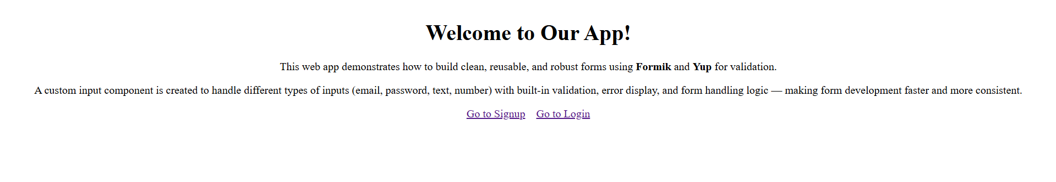

* 1. Signup Page

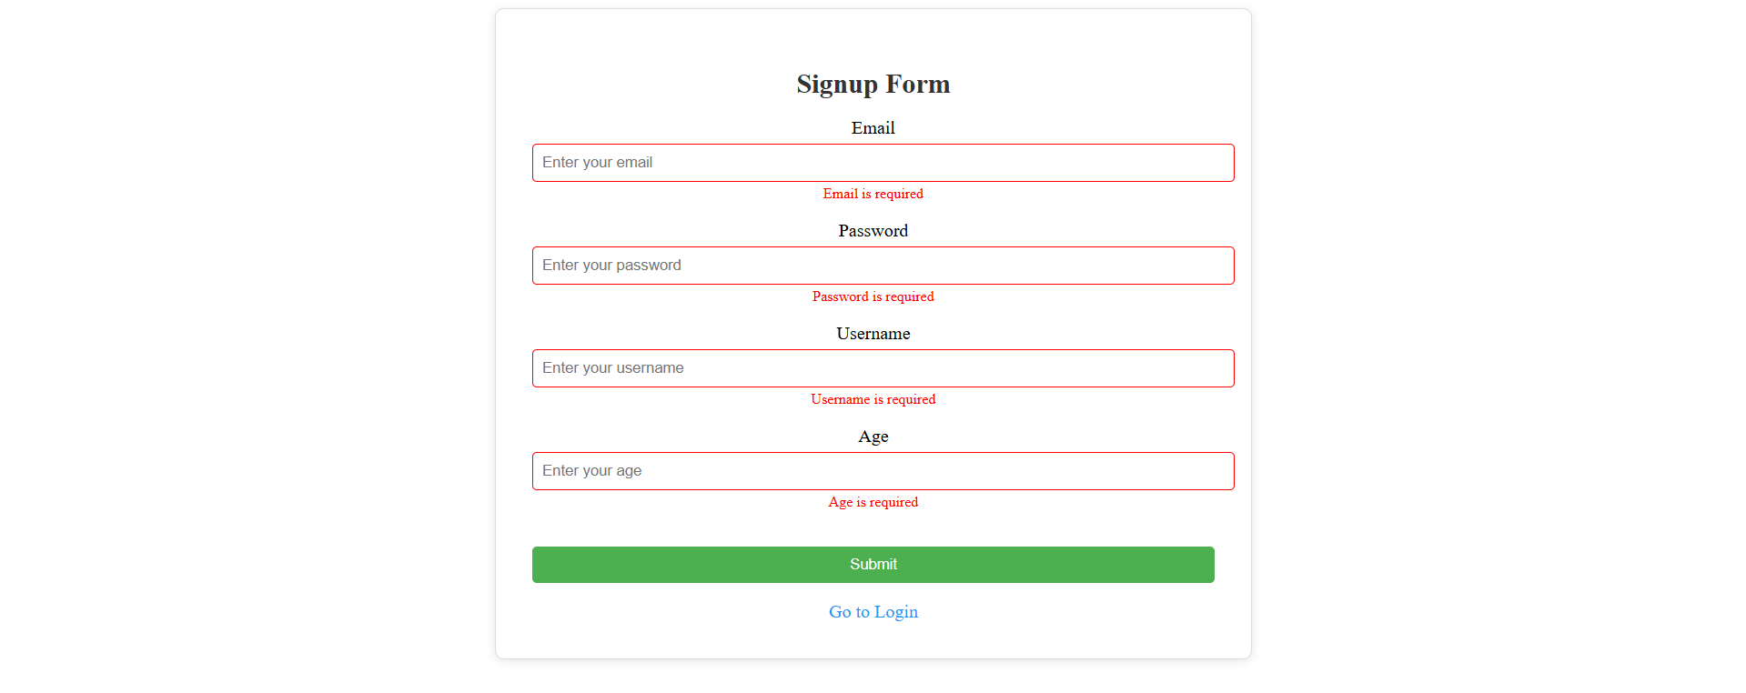

* 1. Login Page

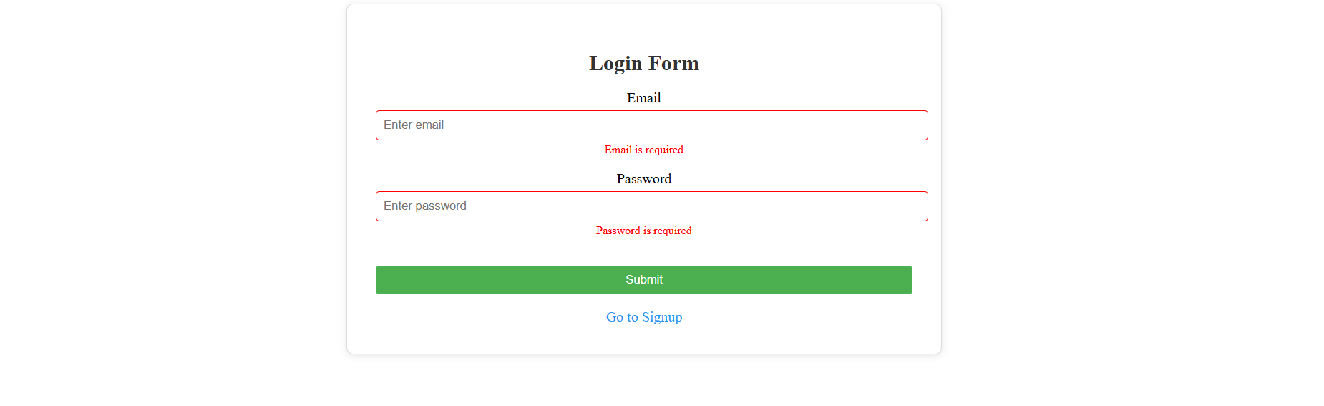

1. **Widget/Algorithm Used in Task:-**
   1. **Formik**: Used for managing form state, handling submission, and form validation integration.
   2. **Yup:** Used for defining validation schemas, such as required fields, regex matching for email/password, and numeric constraints for age.
   3. **React Router:** Used for routing between the home, login, signup and 404.
   4. Email field uses regex to match standard email format.
   5. Password field requires minimum 6 characters, at least one uppercase letter, one lowercase letter, one number, and one special character.
   6. Username must be at least 3 characters and only contain letters, numbers, and underscores.
   7. Age must be between 18 and 99.
   8. After successfully writing all the detail perfecting the output will be shown in the console.